PUSH NOTIFICATION

Overview:

The application checks precipitation values for the 24 and 48 hr timeframe from xml files that MSC provides. 6 areas are being monitored and there are 3 primary stations that the program checks, each having a secondary station. Based on criteria provided, the application will send an email to a specific distribution list if a limit has exceeded. Also, an email will be sent internally to EC staff if there are no precipitation values found or no calculation possible. There will be a link to the application provided so biologists can access all available precipitation information for the current day and 4 previous days. (Ex. In the event there are missing values from the provided MSC data.)

Areas that need to be monitored:

1. Baie de Caraquet (25 mm for 24 hrs, 38 mm for 48 hrs) - (Sep 20 - Nov 15)

2. Tabusintac Bay (25 mm for 24 hrs, 38 mm for 48 hrs) – (Sep 20 - Nov 15)

2. Pocologan Harbour (25 mm for 24 hrs, 37.5 mm for 48 hrs) - (Nov 1 – Mar 31)

3. Letang Harbour (18 mm for 24 hrs, 36 mm for 48 hrs) - (Nov 1 – Mar 31)

4. Digdeguash Harbour (12.5 mm for 24 hrs, 25 mm for 48 hrs) - (Oct 1 – Apr 30)

5. Bocabec River & Mill Cove (12.5 mm for 24 hrs, 25 mm for 48 hrs) - (Oct 1 – Apr 30)

6. Oak Bay & Waweig River (25 mm for 24 hrs, 38 mm for 48 hrs) - (Dec 1 - Mar 31)

PRIMARY STATIONS | SECONDARY STATIONS
Bas-Caraquet | Miscou Island
Miramichi | Bas-Caraquet
Point Lepreau | St. Stephen
St. Stephen | Point Lepreau

How it works:

1. Baie de Caraquet (25 mm for 24 hrs, 38 mm for 48 hrs) - (Sep 20 - Nov 15)

This area uses the "Bas-Caraquet" station. It first checks to see if there are precipitation values for both the 24 and 48 marks. If there are no values, it checks the secondary station, "Miscou Island". If no values appear for both, an email will be sent to the project leads, Bernard and/or Pat.

If values exist for the primary station, it checks to see if the values are within the limit for the 24 and 48 hr mark. If they are, nothing is done. If the values exceed, an email will be sent to a specific distribution list for that area. Max: 2 emails

If values do not exist for the primary station the application checks the secondary station and applies the same criteria.

2. Tabusintac (25 mm for 24 hrs, 38 mm for 48 hrs) - (Sep 20 - Nov 15)

This area uses the "Miramichi" station. It first checks to see if there are precipitation values for both the 24 and 48 marks. If there are no values, it checks the secondary station, "Bas-Caraquet". If no values appear for both, an email will be sent to the project leads, Bernard and/or Pat.

If values exist for the primary station, it checks to see if the values are within the limit for the 24 and 48 hr mark. If they are, nothing is done. If the values exceed, an email will be sent to a specific distribution list for that area. Max: 2 emails

If values do not exist for the primary station the application checks the secondary station and applies the same criteria.

3. Pocologan Harbour (25 mm for 24 hrs, 37.5 mm for 48 hrs) - (Nov 1 – Mar 31)
Letang Harbour(18 mm for 24 hrs, 36 mm for 48 hrs) - (Nov 1 - Mar 31)

These areas use the "Point Lepreau” station. It first checks to see if there are precipitation values for both the 24 and 48 marks. If there are no values, it checks the secondary station, "St. Stephen". If no values appear for both, an email will be sent to the project leads, Bernard and/or Pat. If no value, 2 emails will be sent cause there are 2 areas for the station.

If values exist for the primary station, it checks to see if the values are within the limit for the 24 and 48 hr mark. If they are, nothing is done. If the values exceed, an email will be sent to a specific distribution list for the area. (ex. If Point Lepreau precipitation values exceed for Letang Harbour 1 email is sent for that area.) Max: 4 emails.

If values do not exist for the primary station the application checks the secondary station and applies the same criteria.

4. Digdeguash Harbour (12.5 mm for 24 hrs, 25 mm for 48 hrs) - (Oct 1 - Apr 30)
Bocabec River & Mill Cove (12.5 mm for 24 hrs, 25 mm for 48 hrs) - (Oct 1 - Apr 30)
Oak Bay & Waweig River (25 mm for 24 hrs, 38 mm for 48 hrs) - (Dec 1 - Mar 31)

These areas use the "St. Stephen” station. It first checks to see if there are precipitation values for both the 24 and 48 marks. If there are no values, it checks the secondary station, "Point Lepreau". If no values appear for both, an email will be sent to the project leads, Bernard and/or Pat. If no values, 3 emails will be sent cause there are 3 areas for the station.

If values exist for the primary station, it checks to see if the values are within the limit for the 24 and 48 hr mark. If they are, nothing is done. If the values exceed, an email will be sent to a specific distribution list for that area. . (ex. If St. Stephen precipitation values exceed for "Digdeguash" and “Oak Bay & Waweig River", 1 email is sent for each area.) Max: 6 emails.

If values do not exist for the primary station the application checks the secondary station and applies the same criteria.

Important Information:

1. There is potential for 12 emails per day. Seeing there is 6 conditional areas and 2 station assessments (24 and 48 hrs) per area, if both values exceed an email is sent for each exceeded value. This could occur for 2 days. (ex. If the 24 hr value exceeds for both the 24 and 48 check, that value then gets push to the 48 hr value for the next day, which then exceeds for the new 48 hr value.)

2. Sometimes it occurs that the value for 24 or 48 hrs is "Trace" which means there is little to no precipitation. When this happens a value of 0 will be given for the occurrence seeing the value is actually less then 0.1.

3. Sometimes the 24 hr assessment has no value. When this occurs an email will be sent to the project leader(s) saying that they will have to go in a manually check the station in question.

4. Sometimes the 48 hr assessment cannot be calculated. This occurs when there is no value for the 24 hr check or when the 48 hr check has no value. When this occurs an email will be sent to the project leader(s) saying that they will have to go in a manually check the station in question.

5. Application Location: http://dartgis8/PushNotification/index.aspx

The application displays all station names and 5 days of precipitation data. The textbox above the precipitation information is where the 24 hr and 48 hr values are populated for each station monitoring the 6 conditional areas and is what will be sent as part of the email to notify users of exceeded / non-calculated / no values.

***To view precipitation values without the risk of send additional emails please visit: http://dartgis8/PushNotification/nb.aspx

Email Template:

Subject : RAINFALL CRITERION EXCEEDED - [Insert Name] CMP

Body:

Please be advised that [xx] mm of rainfall has been recorded at [precip station name] in the past [yy] hours. As a result of this precipitation event, there is reason to believe that shellfish harvested from the waters of [insert name] are at risk of being contaminated. In accordance with the Conditional Management Plan for the area, the conditionally-managed waters of [insert name] should immediately be placed in Closed Status.

Environment Canada and the CFIA will advise you when the area may be re-opened.

CRITÈRE DE PLUIE EXCÉDÉ - PGC [insérez nom]

Cet avis est pour vous informer que [xx] mm de pluie furent enregistrés à [nom station météorologique] dans les dernières [yy] heures. En raison de ces fortes précipitations, il y a raison de croire que les mollusques récoltés dans les eaux de [insérez nom] sont possiblement contaminés. Conformément au plan de gestion conditionnel de la région, la portion gérée conditionnellement de [insérez nom] devrait immédiatement être placée en état fermé.

Environnement Canada et l'ACIA aviseront lorsque la région pourra être rouverte

View of Email:

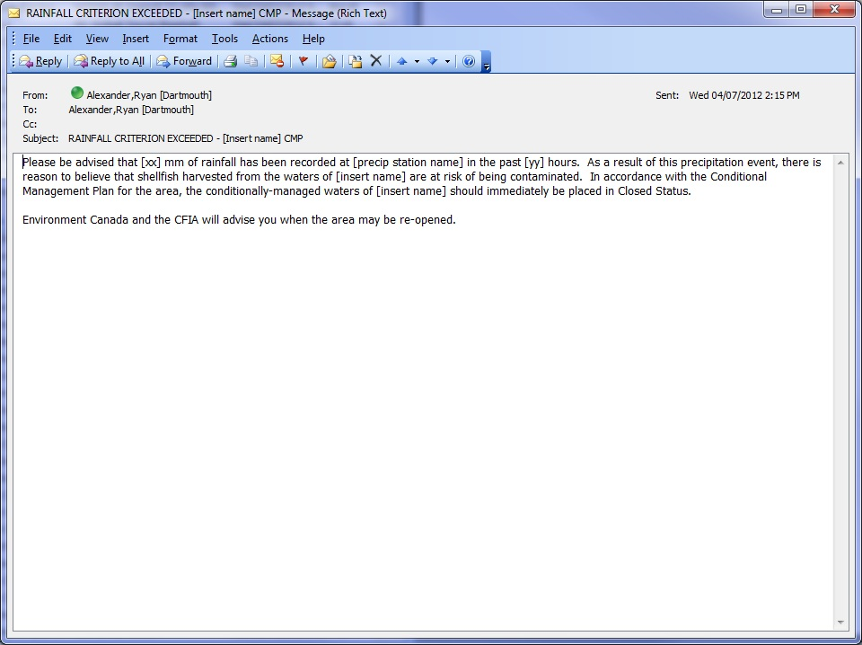

View of Precipitation Amounts:

